Energy Health impact Calculator XX Hospital: Energy and health
Why energy and health: Statistics to pull for various audiences - delete what you don’t need, and/or add locally relevant information/examples:
Energy and health care:
- Hospitals are highly energy-intensive, using 2.5 times more energy per square foot than an office building of the same size.
- The U.S. health care sector spends over $9.5 billion on energy each year.
- At a 5% operating margin, every $1 a nonprofit health care organization saves on energy is equivalent to generating $20 in new patient revenue.

Energy and health:
Emissions from fossil fuels are linked with respiratory problems, neurological damage, heart attacks, cancer, premature death, and other serious health problems. These health impacts are not distributed equally, with vulnerable populations experiencing disproportionate effects from pollution and climate change. Transitioning to clean, renewable energy in the U.S. could:
- prevent 52,000 premature deaths annually
- save $167 billion in health costs over 35 years
Locally, we see XXX problems (asthma, cardiovascular, extreme weather, wildfire, flooding, etc. and their health impacts and costs). We have an opportunity to increase our ability to improve community health, recruit and retain good personnel, align with our patients’ and donors’ needs and values by considering doing XXX.

Energy use at XX Hospital
- x,xxx,xxx kWh (or MWh)
- yyy,yyy,yyy therms, cf, btus, etc.
- In recent years we have (insert any major energy efficiency, clean energy or other relevant efforts)
How the Calculator works
The Energy and Health Impact Calculator is a free tool developed by Health Care Without Harm and Practice Greenhealth to help health care facilities and other users assess the health impacts of their electricity and thermal energy consumption.

The Calculator converts user-input electricity and thermal energy consumption data into expected health and welfare impacts, which include illness, premature mortality, missed workdays, and other effects. These results are valued using standardized rates. Both emissions and endpoint results, and their associated values, are output to the user.
Based on the geographic information provided by the user, the Calculator evaluates emissions impacts at the grid-regional level, predicting county-level associated emissions totals or emissions changes, using the EPA AVERT topology that divides the contiguous United States into ten discrete regions. Emissions impacts are evaluated similarly at the county-level for the entire contiguous United States.
This process can be visualized in five distinct steps, presented in the figure below.

Step 1: user inputs energy data

Step 2: energy data converted to emissions results

Step 3: emissions results converted to endpoint incidence

Step 4: valuation of endpoint incidence

Step 5: results reported to user
Note that the individual steps shown above may reflect multiple operations. For example in step 2, energy data is converted to emissions results using factors that are specific to the different energy sources – including grid electricity, renewable energy, and onsite fuel combustion – different factors are used to evaluate total energy consumption (average emissions) versus change in energy consumption (marginal emissions). Converting emissions to endpoint incidences in step 3 involves the use of a transport model to predict where emissions from specific power plants in the region of interest will end up, illustrating where they will end up impacting health and welfare.
[Insert your Total / electricity / delivered fuels health impact results]
Based on the following data from [HOSPITAL]
XXX kWh electricity
XXX mmBtu natural gas

A full circle (●) indicates that the value is included in the total estimated value, but cannot be separately determined; an empty circle (◌) indicates that the value has not been included.

It is true that due to dispersal patterns, social determinants of health and other environmental health factors, health impacts and costs of emissions cannot typically be attributed to a given location and population. That said, the Hippocratic Oath has no geographical limit, no exemption because those harmed might be beyond immediate sight or identified individuals.
Update image with your results

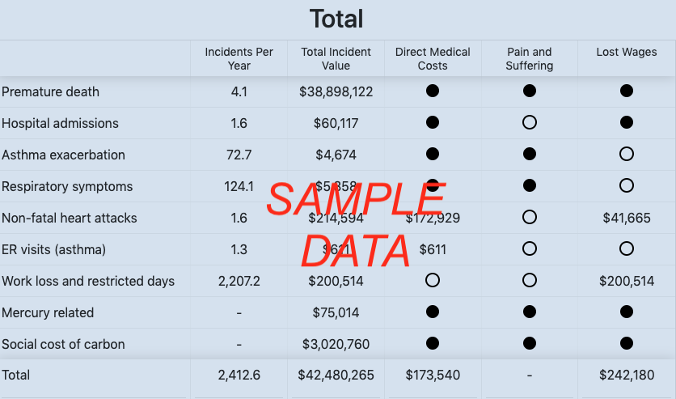

Instructions for embedding the table above:

- From the web version of the Calculator, choose the “download image” button to download a PNG format. Save the file in a folder you can easily find later. In this Word file, choose insert->picture, then browse to the folder location where you saved the PNG image and select the file to insert.
- In the Excel version of the Calculator, drag your cursor over all the table rows and columns you want to copy. Choose “copy” from the top banner menu or by right-clicking the selection to get a menu of options. In this Word file, choose “paste” or “paste special.” If you choose “paste special,” you will be able to paste as a bitmap image, which will adopt the formatting already built into Word or PowerPoint rather than introducing new formatting from Excel. You can also paste the data as an editable table, which would allow you to format the table and edit its contents.

[Insert your emissions results]
If you’re going to include this, we recommend plugging emissions into the EPA’s Greenhouse Gas Equivalencies Calculator

